# Durable Furnitures

Alfonso

## Brighton Dining Set

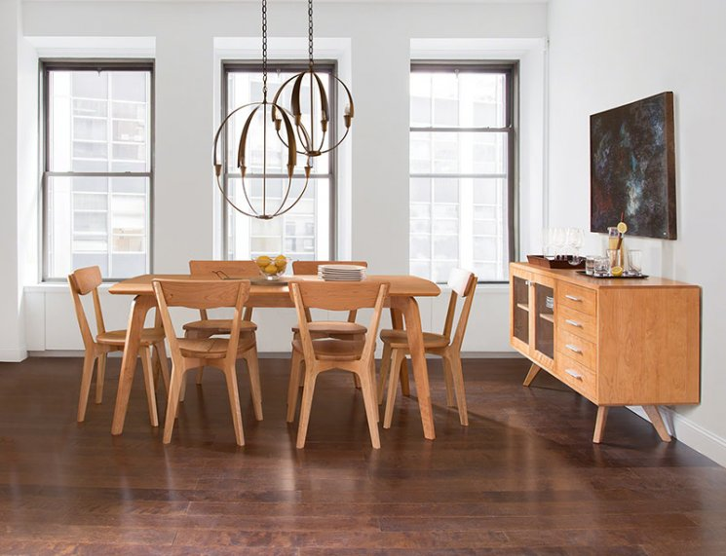

Our Brighton Dining Set simply transcends contemporary style with its widely rounded angles and clean mid-century modern lines. Character and personality are artfully captured in the precise attention to detail carefully applied to every facet of this fine furniture set. The choice of natural cherry or walnut hardwoods only further enhances the modest detailing. Make it a part of your home today.